**CO1 PYTHON PROGRAMS**

1. Familiarizing Text Editor, IDE, Code Analysis Tools etc // Use any IDE.

**Text Editor**

A text editor is a program that saves your files without formatting. Word processors such as MS-Word or OpenOffice.org Writer include formatting information when they save a file -- that is how the program knows to bold certain text and italicize others. Similarly, graphic HTML editors do not save emboldened text as bold text but as text with a bold attribute tag. These tags are meant for visualization, not for computation. Therefore, when the computer reads the text and tries to execute it, it gives up, crashing, as if to say, "How do you expect me to read that?" If you do not understand why it might do this, you may want to revisit how a computer reads a program.

**IDE**

An integrated development environment is a software application that provides comprehensive facilities to computer programmers for software development. An IDE normally consists of at least a source code editor, build automation tools and a debugger.

2. Display future leap years from current year to a final year entered by user.

**Program**

s=int(input("Enter the start year: "))

e=int(input("Enter the end year:"))

if(s<e):

print("Leap years are:",end=" ")

for i in range(s,e):

if i%4==0 and i%100!=0:

print(i,end=" ")

**Output**

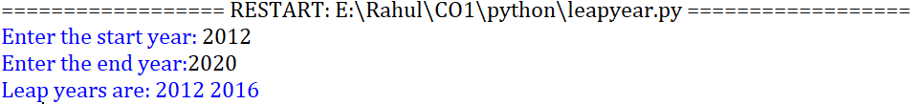

**3.** **List comprehensions:**

i. Generate positive list of numbers from a given list of integers.

**Program**

list=[-2,10,-22,31,54]

re=[num for num in list if num>=0]

print(re)

**Output**



ii. Square of n numbers.

**Program**

n=int(input("Enter the limit: "))

square=[i**2 for i in range(1,n+1)]

print("Square of the numbers: ",square)

**Output**



iii. Form a list of vowels selected from the given word.

**Program**

word=str(input("Enter the word: "))

print("The original string is: ",word)

print("The vowels are: ",end="")

for i in word:

if i in 'aeiouAEIOU':

print([i],end="")

**Output**

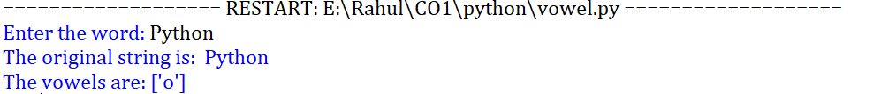

iv. List ordinal value of each element of a word (Hint: use ord() to get ordinal values)

**Program**

w=input("Enter a word:")

print("Ordinal values corresponding to each element is:")

for i in w:

print(i,end=":")

print(ord(i),end=" ")

**Output**

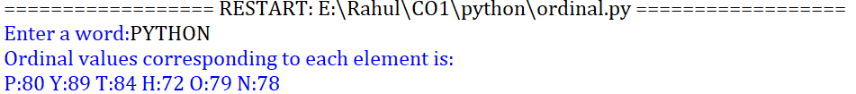

4. Count the occurrences of each word in a line of text.

**Program**

str1 = input("Enter a string : ")

wordlist = str1.split()

count= []

for w in wordlist: count.append(wordlist.count(w))

print("count of the occurrence:" + str(list(zip(wordlist, count))))

**Output**



5. Prompt the user for a list of integers. For all values greater than 100, store ‘over’ instead

**Program**

n=[]

s=int(input("Enter a limit:"))

print("Enter {s} values")

for i in range(0,s):

n.append(int(input()))

print("\nThe list after assinging:\n")

for i in range(0,len(n)):

if n[i]>=100:print("over")

else:

print(n[i])

**Output**

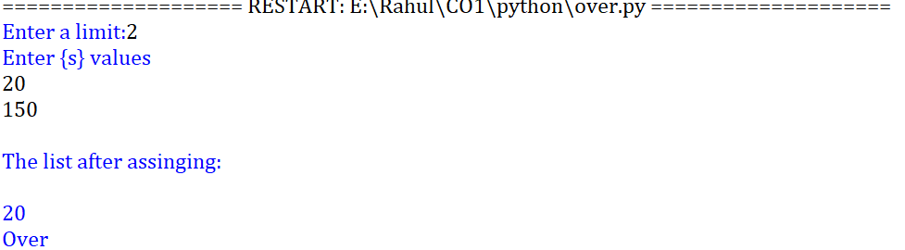

6. Store a list of first names. Count the occurrences of ‘a’ within the list

**Program**

a_list = ["a", "Rahul", "b"]

occ = a_list.count("a")

print("count of occurrences of a :",occ)

**Output**



7. Enter 2 lists of integers. Check (a) Whether list are of same length (b) whether list sums to same value (c) whether any value occur in both.

**Program**

lst=[1,3,5,7,9,11,34]

lst1=[5,13,45,7,20,65,1]

s=int(0)

c=int(0)

if len(lst)==len(lst1):

print("Lists are of same length")

else:

print("Lists have different length")

for i in range(0,len(lst) and len(lst1)):

s=s+lst[i]

c=c+lst1[i]

if(s==c):

print("equal sum")

else:

print("not same sum")

print("Elements that matched are:")

l=[]

for i in range(0,len(lst)):

for j in range(0,len(lst1)):

if lst[i]==lst1[j]:

l.append(lst[i] and lst1[j])

else:

continue

print(l)

**Output**

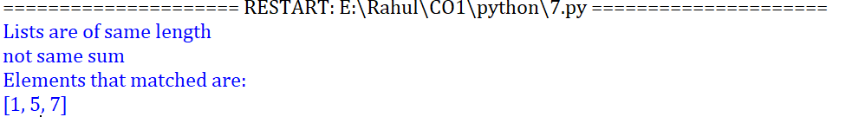

8. Get a string from an input string where all occurrences of first character replaced with ‘$’, except first character. [eg: onion -> oni$n]

**Program**

str1="malayalam"

char = str1[0]

str1=str1.replace(char, '$')

str1=char + str1[1:]

print(str1)

**Output**



9. Create a string from given string where first and last characters exchanged. [eg: python -> nythop]

**Program**

str1=input("Enter a string: ") str2=str1[-1:]+str1[1:-1]+str1[:1]

print("New string: ",str2)

**Output**



10. Accept the radius from user and find area of circle.

**Program**

pi=3.14 r=float(input("Enter the radius of the circle:"))

area=3.14*r*r

print("The area of the circle is: ",area)

**Output**



11. Find biggest of 3 numbers entered.

**Program**

x = int(input("Enter 1st number: "))

y = int(input("Enter 2nd number: "))

z = int(input("Enter 3rd number: "))

if (x > y) and (x > z):

largest = x

elif (y > x) and (y > z):

largest = y

else:

largest = z

print("The largest number is",largest)

**Output**

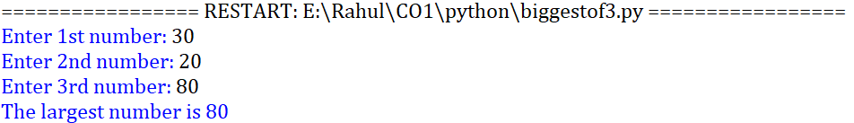

12. Accept a file name from user and print extension of that.

**Program**

file= input("Enter filename : ")

f=file.split(".")

print("Extension of the file is : " + f[-1])

**Output**



13. Create a list of colors from comma-separated color names entered by user.Display first and last colors.

**Program**

a=[]

for i in range(3):

b=input("enter the color:")

a.append(b)

print(a)

print(a[0])

print(a[2])

**Output**

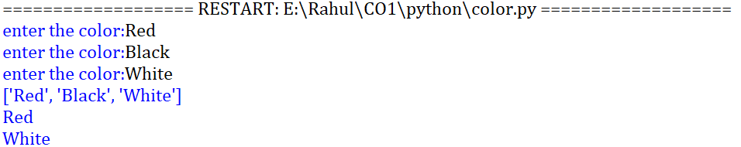

14. Accept an integer n and compute n+nn+nnn

**Program**

n =int(input("Enter a number : "))

x = int( "%s" % n )

y = int( "%s%s" % (n,n) )

z = int( "%s%s%s" % (n,n,n) )

print("n + nn + nnn :",x+y+z)

**Output**



15. Print out all colors from color-list1 not contained in color-list2.

**Program**

color-list1=set(["Yellow","White","Red","Gold","Black"])

color-list2=set(["Yellow"])

print(color-list1.difference(color-list2))

**Output**



16. Create a single string separated with space from two strings by swapping the character at position 1.

**Program**

a="Madrid"

b="Barcelona"

p1=a[0]

p2=b[0]

c=b[0]+a[1:]+" "+a[0]+b[1:]

print(c)

**Output**



17. Sort dictionary in ascending and descending order.

**Program**

import operator

d={"Rahul":2,"Jerin":4,"Ananthu":3,"Amal":1,"Fabin":0}

print('Original dictionary: ',d)

print()

sorted_d=sorted(d.items(),key=operator.itemgetter(1))

print('Dictionary in ascending order by value',sorted_d)

sorted_d=dict(sorted(d.items(),key=operator.itemgetter(1),reverse=True))

print('Dictionary in descending order by value:',sorted_d)

**Output**

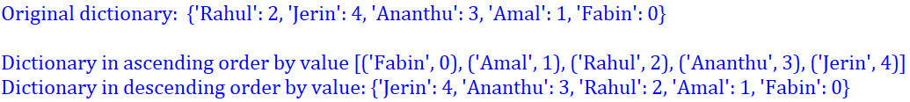

18. Merge two dictionaries.

**Program**

import operator

d1= {"Rahul":23,"Arun":5}

d2={"Ananthu":151,"Sooraj":2}

print("Dictionary 1:",d1)

print("Dictionary 2:",d2)

d=d1.copy()

d.update(d2)

print("Merged Dictionary: ",d)

**Output**

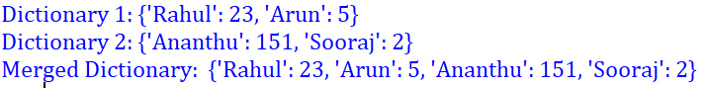

19. Find GCD of 2 numbers.

**Program**

x= int(input("Enter 1st number: "))

y= int(input("Enter 2nd number: "))

i = 1

while(i <= x and i <= y):

if(x % i == 0 and y% i == 0):

gcd = i

i = i + 1

print("GCD :", gcd)

**Output**

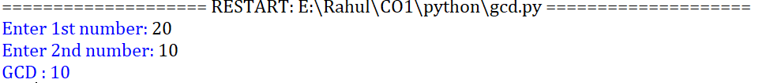

20. From a list of integers, create a list removing even numbers.

**Program**

num = [7,8, 120, 25, 44, 20, 27]

print( "Original list:",num)

num = [x for x in num if x%2!=0]

print("list after removing even numbers:",num)

**Output**

